**General Test Method for Straight Thread Verification**

[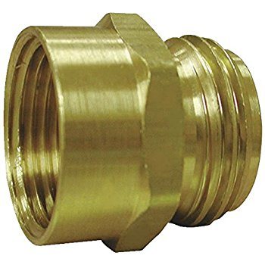](https://www.google.com/url?sa=i&rct=j&q=&esrc=s&source=images&cd=&cad=rja&uact=8&ved=0ahUKEwiZvZPwzZvXAhVqxYMKHWCrAfIQjRwIBw&url=https://www.amazon.com/Stephens-G20-110-4-Inch-2-Inch-Female/dp/B00529CITU&psig=AOvVaw0Is6pqOCZnBpvGzWn0R1Ea&ust=1509564951715403)

CONTENTS

1 Equipment 3

1.1 Calibrated ¾” – 11.5 NHT Female Thread Gauge (Go/No-Go) 3

1.2 Calibrated ¾” – 11.5 NHT Male Thread Gauge (Go/No-Go) 3

2 Software 3

3 Setup 3

3.1 Male Hose Thread Setup: 3

3.2 Female Hose Thread Setup: 3

4 General Test Procedure 4

4.1 Verifying Male Hose Threads 4

4.2 Verifying Female Hose Threads 5

5 Data Format and Reporting 5

5.1 Section 4.1 5

5.2 Section 4.2 5

1. Equipment

The following equipment is used as an example for this testing:

Note: This procedure is applicable for all straight thread gauges, not only NHT gauges.

* 1. Calibrated ¾” – 11.5 NHT Female Thread Gauge (Go/No-Go)

Used to verify male hose thread. The “Go” gauge should fully thread on with little to no torque, while the “No-Go” gauge should not fully thread on.

* 1. Calibrated ¾” – 11.5 NHT Male Thread Gauge (Go/No-Go)

Used to verify female hose thread. One side is a “Go” gauge, which should fully thread in with little to no torque, while the opposite side is a “No-Go” gauge, which should not fully thread in.

1. Software

None Required

1. Setup
   1. Male Hose Thread Setup:

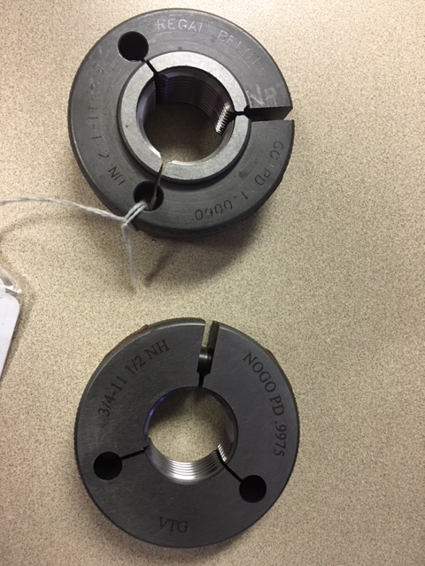

* + 1. Female Thread Gauges (Go/No-Go)
  1. Female Hose Thread Setup:

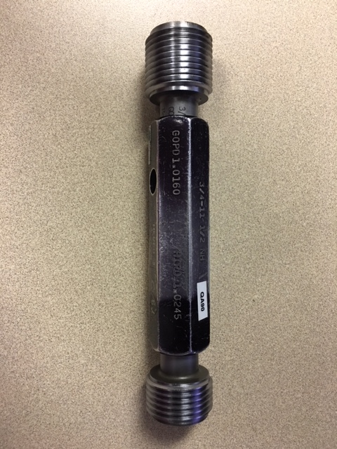

* + 1. Male Thread Gauges (Go/No-Go)

Set-up Instructions and photos.

1. General Test Procedure
   1. Verifying Male Hose Threads
      1. Ensure gauges and product threads are clean and dry.
      2. Using your thumb and an opposing finger, thread the Go Gauge onto the product threads *(Fig 1)*.

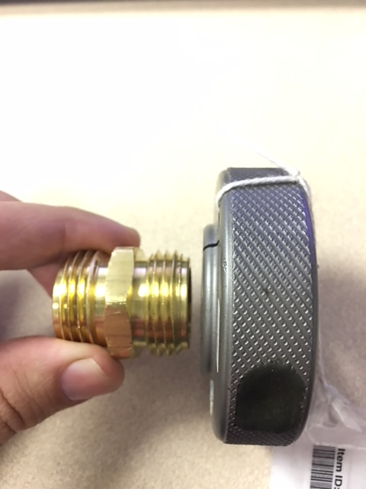 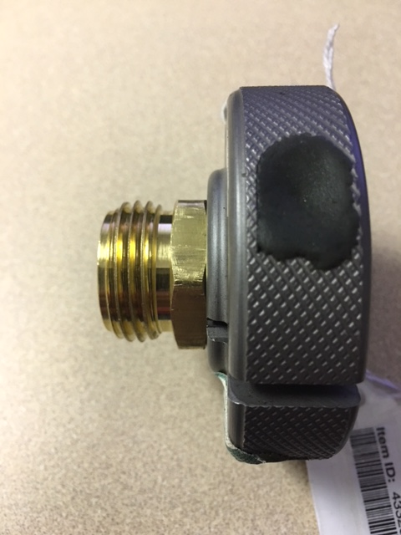

*Figure 1: Threading Go Gauge*

* + 1. The Go Gauge should thread fully onto the entire length of the product threads.
    2. If the gauge does not thread fully on, the threads may be too big or malformed. The product should be rejected upon this failure.
    3. Unthread the Go Gauge and thread the No-Go Gauge onto the threads *(Fig 2)*.

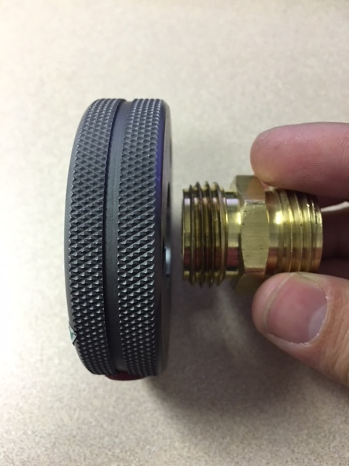 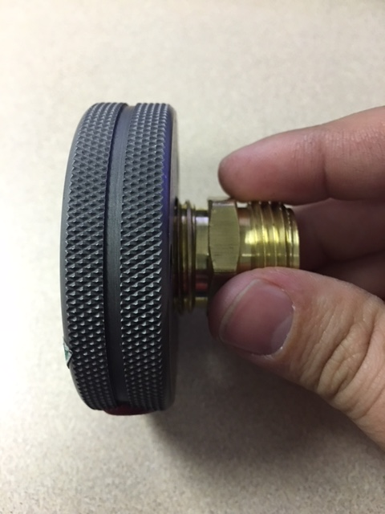

*Figure 2: Threading No-Go Gauge*

* + 1. Using your thumb and an opposing finger, the No-Go Gauge should thread no more than 1.00 turns onto the product threads.
    2. If the No-Go gauge is able to thread more than 1.00 turns, the threads may be too small or malformed. The product should be rejected upon this failure.
  1. Verifying Female Hose Threads
     1. Ensure gauges and product threads are clean and dry. Remove the hose washer if present.
     2. Using your thumb and an opposing finger, thread the Go Gauge into the product threads *(Fig 3)*.

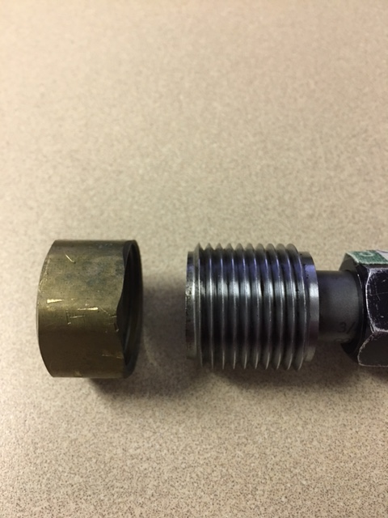 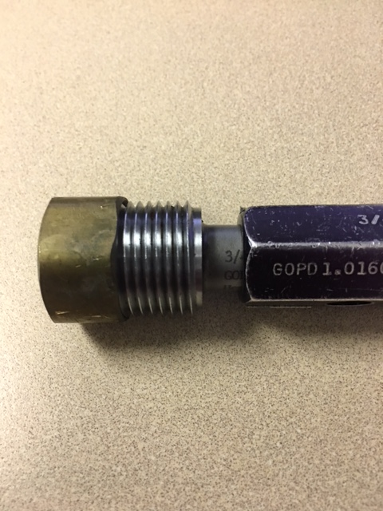

*Figure 3: Threading Go Gauge*

* + 1. The Go Gauge should thread fully into the entire length of the product threads.
    2. If the gauge does not thread fully in, the threads may be too small or malformed. The product should be rejected upon this failure.
    3. Unthread the Go Gauge and thread the No-Go Gauge into the threads *(Fig 4)*.

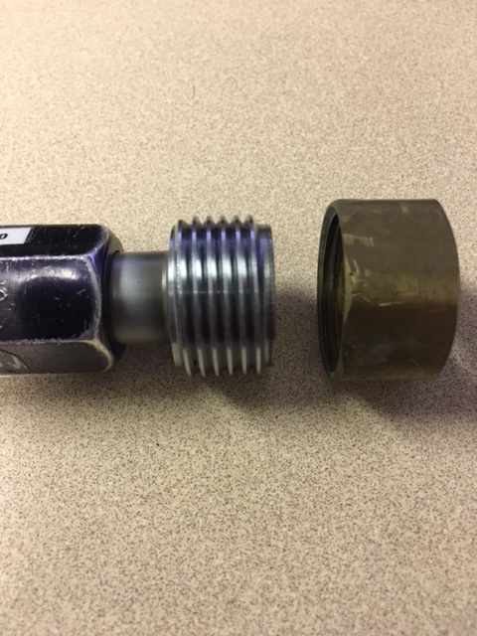 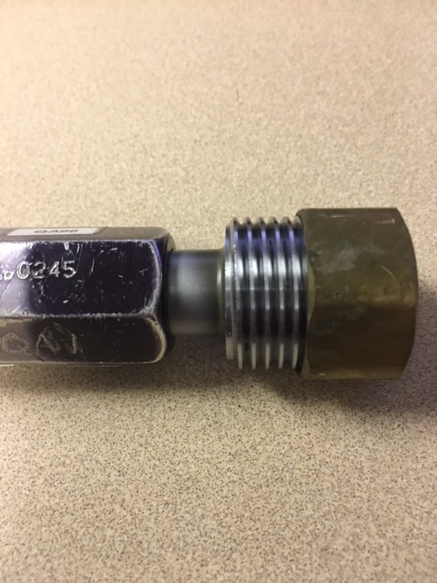

*Figure 4: Threading No-Go Gauge*

* + 1. Using your thumb and an opposing finger, the No-Go Gauge should thread no more than 1.00 turns into the product threads.
    2. If the No-Go gauge is able to thread more than 1.00 turns, the threads may be too big or malformed. The product should be rejected upon this failure.

1. Data Format and Reporting
   1. Section 4.1
      1. Go Gauge acceptance status.
      2. No-Go Gauge number of turns to remove from thread.
   2. Section 4.2
      1. Go Gauge acceptance status.
      2. No-Go Gauge number of turns to remove from thread.

* END *